Benchmark Systems
Modeling Description
Abstract: This document describes the modeling of the Benchmark Examples using the OpenDSS Library from the Typhoon HIL toolchain. The main goal of these systems is to support a starting point for the usage of the library applying its key features. The library modeling technique/features are applied according to the electrical system characteristics in the study.
Contents
OTHER Systems 1
BANSHEE DISTRIBUTION NETWORK (MICROGRID) 1
Results 3
Modeling Data 4
References 6

OTHER Systems

BANSHEE DISTRIBUTION NETWORK (MICROGRID)
The Banshee benchmark corresponds to a real-life small industrial facility, which reproduces typical microgrid challenges worldwide. Three utility feeders service the power plant at 13.8 kV levels (Figure 1) that may interconnect through normally open tie switches. Twenty-two (22) distribution transformers reduce the 13.8 kV to service voltages of 4.16 kV, 480 V, and 208 V.
Eighteen (18) aggregated low voltage loads (480 V and 208 V) are classified as critical, priority, or interruptible (all loads are modeled as constant power mode). In that way, several circuit breakers perform a load-shedding logic on the microgrid controller according to the load classification. All circuit breakers on the power plant are modeled as static switches, although they should be changed to controlled switches according to the model applications.
Banshee also includes two large induction motors (200 HP) connected with the P1 and P6 loads. However, as motors are not present in the current Typhoon OpenDSS library, it still needs to be considered on the model in future versions. The same is applied to the PV generation connected to bus #202. In this context, BESS and synchronous generators of the power plant also are not used in this modeling version.
Figure 2 show how to execute a snapshot simulation from the OpenDSS engine by clicking the “Run” button on the “Simulation” tab of the SimDSS component. The power flow results are accessed by the “Show” properties tab (Figure 2.b). After compiling and loading the model into the HIL, the user can observe a similar operational point as shown in the Results section. The power flow results compared in Table 1 – Table 3 show the match between the Typhoon model and the reference. The DSS column refers to the results obtained from the SimDSS component from the Schematic Editor, and the SCADA column is the steady state voltages from the runtime simulation.
It’s worth mentioning two points about the results:
- Several TLM core coupling components divide the model resources due to the power plant size. That kind of core coupling has some advantages in terms of stability compared to the ITM method, but it adds shunt capacitance to the model, which can be significant if the inductance of the TLM is small. To minimize that behavior, all TLM is placed inside the transformers. Even though those capacitors impact the system, as shown in Table 1 and Table 3, when significative errors are observed only on the SCADA tab. On the power flow impact, it is possible to see differences of around 30% in the reactive power flowing in some circuits. From the voltage viewpoint, it is also possible to check the capacitors' impact in over-voltages in some buses, in the worst cases, assuming values greater than 1.0 pu.
- CB102 flow has significant errors in both DSS and SCADA tabs. Comparing the data entry of the source code from the reference was noted a different input for the reactive power in a load of this branch. The model will use the load value from the reference paper instead.

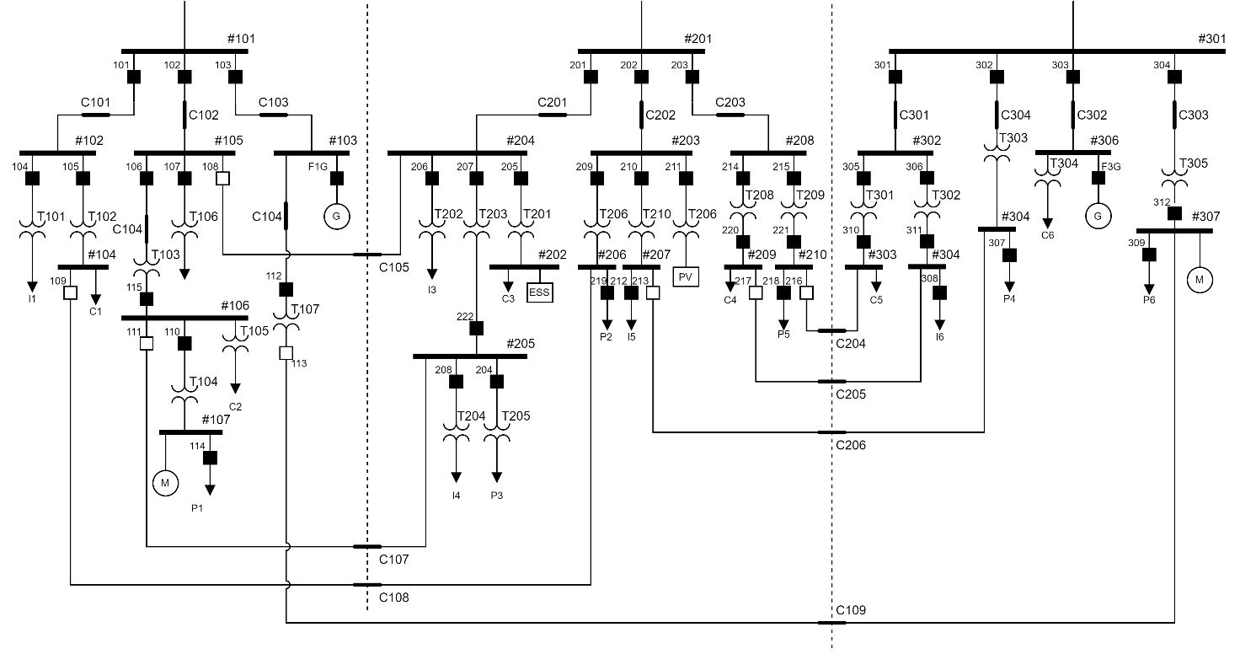
Figure 1 – Single Line diagram of the Banshee Microgrid.

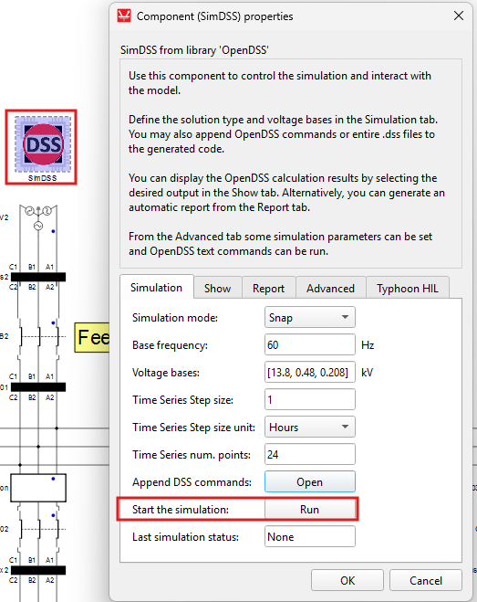 | 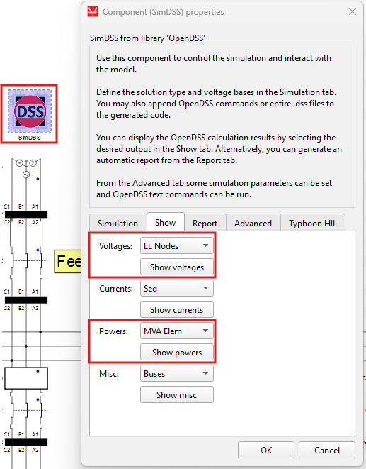
a) | b)
Figure 2 – a) Running the OpenDSS simulation and b) getting the power flow results.

Results
Table 1. Power Flow at feeders PCC.
Circuit Breaker | REF. |  | DSS |  | SCADA
Circuit Breaker | MW | Mvar | MW | Mvar | MW | Mvar
CB101 | 1.37 | 0.70 | 1.36 | 0.71 | 1.37 | 0.68
CB102 | 2.53 | 1.09 | 2.48 | 1.39 | 2.51 | 1.35
CB103 | 0.00 | 0.00 | 0.00 | 0.00 | 0.00 | -0.02
CB201 | 2.67 | 1.40 | 2.64 | 1.41 | 2.65 | 1.41
CB202 | 1.28 | 0.65 | 1.27 | 0.65 | 1.27 | 0.86
CB203 | 1.55 | 0.76 | 1.54 | 0.79 | 1.54 | 0.92
CB301 | 1.46 | 0.74 | 1.46 | 0.75 | 1.46 | 0.70
CB302 | 0.55 | 0.29 | 0.55 | 0.28 | 0.55 | 0.27
CB303 | 0.74 | 0.39 | 0.73 | 0.39 | 0.74 | 0.39
CB304 | 0.91 | 0.46 | 0.91 | 0.47 | 0.91 | 0.46
Table 2. Power Flow errors at feeders PCC.
Circuit Breaker | DSS |  | SCADA
Circuit Breaker | MW | Mvar | MW | Mvar
CB101 | 0.39% | -0.81% | 0.00% | 2.86%
CB102 | 1.98% | -27.32% | 0.79% | -23.85%
CB103 | -- | --
CB201 | 1.01% | -0.36% | 0.75% | -0.71%
CB202 | 0.58% | 0.00% | 0.78% | -32.31%
CB203 | 0.44% | -3.87% | 0.65% | -21.05%
CB301 | 0.15% | -1.00% | 0.00% | 5.41%
CB302 | 0.55% | 1.76% | 0.00% | 6.90%
CB303 | 1.39% | 0.56% | 0.00% | 0.00%
CB304 | -0.38% | -2.17% | 0.00% | 0.00%

Table 3. Load Voltages Magnitudes and errors.
Load ID | REF  Voltage | DSS |  | SCADA
Load ID | REF  Voltage | Voltage | Error | Voltage | Error
C1 | 0.978 | 0.967 | 1.08% | 0.976 | 0.20%
C2 | 0.950 | 0.941 | 0.94% | 0.942 | 0.84%
C3 | 0.982 | 0.971 | 1.10% | 1.000 | -1.83%
C4 | 0.976 | 0.971 | 0.52% | 0.997 | -2.15%
C5 | 0.977 | 0.967 | 1.03% | 0.974 | 0.31%
C6 | 0.964 | 0.961 | 0.33% | 0.961 | 0.31%
P1 | 0.960 | 0.944 | 1.63% | 0.952 | 0.83%
P2 | 0.982 | 0.970 | 1.20% | 1.035 | -5.40%
P3 | 0.949 | 0.948 | 0.08% | 0.953 | -0.42%
P4 | 0.973 | 0.965 | 0.78% | 0.970 | 0.31%
P5 | 0.984 | 0.990 | -0.65% | 1.048 | -6.50%
P6 | 0.982 | 0.966 | 1.61% | 0.979 | 0.31%
I1 | 0.974 | 0.972 | 0.20% | 0.973 | 0.10%
I2 | 0.976 | 0.973 | 0.34% | 0.974 | 0.20%
I3 | 0.969 | 0.966 | 0.34% | 0.993 | -2.48%
I4 | 0.962 | 0.950 | 1.28% | 0.956 | 0.62%
I5 | 0.982 | 0.972 | 0.98% | 1.031 | -4.99%
I6 | 0.986 | 0.973 | 1.28% | 0.982 | 0.41%

Modeling Data
Table 4. Cable Type Impedances.
Cable Type | R1 (Ω/km) | X1 (Ω/km) | R0 (Ω/km) | X0 (Ω/km)
15kV Shielded 4/0 AWG 3C CU | 0.1668 | 0.1286 | 1.3302 | 0.9830
15kV Shielded 500KCMIL SR 3C CU | 0.0749 | 0.1167 | 1.1405 | 0.7559

Table 5. Line Segment Data.
Line | From (#Bus) | To  (#Bus) | Cable Type | Length  ft (km) | Line | From (#Bus) | To  (#Bus) | Cable Type | Length  ft (km)
C101 | #101 | #102 | 500 kcmil | 1800 (0.549) | C201 | #201 | #204 | 4/0 AWG | 5500 (1.676)
C102 | #101 | #105 | 500 kcmil | 5500 (1.676) | C202 | #201 | #203 | 500 kcmil | 2000 (0.610)
C103 | #101 | #103 | 4/0 AWG | 1000 (0.305) | C203 | #201 | #208 | 500 kcmil | 3000 (0.914)
C104 | #101 | #T107 | 500 kcmil | 3000 (0.914) | C204 | #210 | #303 | 500 kcmil | 1500 (0.457)
C105 | #105 | #204 | 500 kcmil | 3000 (0.914) | C205 | #209 | #304 | 500 kcmil | 1500 (0.457)
C106 | #105 | #106 | 500 kcmil | 1500 (0.457) | C206 | #207 | #305 | 500 kcmil | 1500 (0.457)
C107 | #106 | #205 | 500 kcmil | 2000 (0.610) | C301 | #301 | #302 | 500 kcmil | 2500 (0.762)
C108 | #104 | #206 | 500 kcmil | 1000 (0.305) | C302 | #301 | #306 | 4/0 AWG | 2000 (0.610)
C109 | #T107 | #307 | 500 kcmil | 2000 (0.610) | C303 | #301 | #307 | 500 kcmil | 2000 (0.610)
 |  |  |  |  | C304 | #301 | #305 | 4/0 AWG | 1500 (0.457)

Table 6. Load Data.
Classification | ID | Connection | Demand  kVA | Classification | ID | Connection | Demand  kVA
Critical | C1 | #104 | 1200 | Critical | C4 | #209 | 1000
Critical | C2 | #106 (T105) | 1500 | Critical | C5 | #303 | 1000
Critical | C3 | #202 | 1000 | Critical | C6 | #306 (T304) | 800
Priority | P1 | #107 | 1000 | Priority | P4 | #305 | 600
Priority | P2 | #206 | 1000 | Priority | P5 | #210 | 700
Priority | P3 | #205 (T205) | 1000 | Priority | P6 | #307 | 1000
Interruptible | I1 | #102 (T101) | 300 | Interruptible | I4 | #205 (T204) | 600
Interruptible | I2 | #105 (T106) | 250 | Interruptible | I5 | #207 | 400
Interruptible | I3 | #204 (T202) | 300 | Interruptible | I6 | #304 | 600

Table 7. Transformers Data.
ID | Nameplate |  |  |  |  | Computed
ID | Rating  [kVA] | Vpri  [kV] | Vsec  [kV] | Z  [%] | X/R | X  [%] | R  [%]
T101 | 500 | 13.8 | 0.48 | 5.00 | 4.9 | 4.90 | 1.00
T102 | 2500 | 13.8 | 0.48 | 5.75 | 6.6 | 5.69 | 0.86
T103 | 3750 | 13.8 | 4.16 | 4.75 | 11.4 | 4.73 | 0.42
T104 | 2000 | 4.16 | 0.48 | 5.75 | 4.7 | 5.62 | 1.20
T105 | 2000 | 4.16 | 0.48 | 5.75 | 4.7 | 5.62 | 1.20
T106 | 500 | 13.8 | 0.208 | 5.00 | 4.9 | 4.90 | 1.00
T107 | 2500 | 13.8 | 0.48 | 5.75 | 6.6 | 5.69 | 0.86
T201 | 2500 | 13.8 | 0.48 | 5.56 | 5.5 | 5.47 | 0.99
T202 | 500 | 13.8 | 0.208 | 5.00 | 4.9 | 4.90 | 1.00
T203 | 3750 | 13.8 | 4.16 | 4.75 | 11.4 | 4.73 | 0.42
T204 | 1000 | 4.16 | 0.48 | 5.75 | 4.2 | 5.59 | 1.33
T205 | 1500 | 4.16 | 0.48 | 5.75 | 5.0 | 5.64 | 1.12
T206 | 2500 | 13.8 | 0.48 | 5.75 | 6.6 | 5.69 | 0.86
T207 | 5000 | 13.8 | 0.48 | 5.00 | 5.4 | 4.92 | 0.90
T208 | 2000 | 13.8 | 0.48 | 5.75 | 4.7 | 5.62 | 1.20
T209 | 2000 | 13.8 | 0.48 | 5.75 | 4.7 | 5.62 | 1.20
T210 | 1000 | 13.8 | 0.48 | 5.75 | 4.2 | 5.59 | 1.33
T301 | 2000 | 13.8 | 0.48 | 5.75 | 4.7 | 5.62 | 1.20
T302 | 2000 | 13.8 | 0.48 | 5.75 | 4.7 | 5.62 | 1.20
T303 | 1000 | 13.8 | 0.48 | 5.75 | 4.2 | 5.59 | 1.33
T304 | 1000 | 13.8 | 0.48 | 5.75 | 4.2 | 5.59 | 1.33
T305 | 2500 | 13.8 | 0.48 | 5.75 | 6.6 | 5.69 | 0.86

References
[1] – Banshee distribution network benchmark and prototyping platform for hardware-in-the-loop integration of microgrid and device controllers. The Journal of Engineering, 2019: 5365-5373. https://doi.org/10.1049/joe.2018.5174
[2] – Electric Power Hardware-in-the-loop Controls Collaborative. Available at https://github.com/PowerSystemsHIL/EPHCC/releases/download/BansheeBenchmark/Supporting.Data.for.Banshee.Benchmark.Paper.zip

